MITS
Material Inventory Tracking System
October, 2018
Current Installed Base in Maryland:
Executive Office of the Governor Department of Budget and Management
Dept. of Information Technology (DOIT) Dept. of Labor and Licensing Regulations
DHMH Spring Grove Hospital Center
Springfield Hospital Center Western Maryland Hospital Center
Maryland Public Television Frederick County Health Dept.
MD School for the Deaf Cecil Country Health Dept.
Gov Office of the Deaf and Hard of Hearing Benneker-Douglas Museum
Volunteer Maryland State Ethics Commission
Gov Office of Crime Control and Prevention Comptroller of Maryland
Gov Office of Minority Affairs Harford County Health Dept.
Gov Office for Children Wicomico County Health Dept.
Maryland Veterans Affairs Maryland State Treasurer
Office of Administrative Hearings Workers Compensation Commission
Maryland Department of Aging Maryland Health Exchange
Maryland Higher Education Commission Maryland Stadium Authority
Clifton Perkins Hospital Center Baltimore County DSS
Maryland Emergency Management Agency

Introduction
The Material Inventory Tracking System (MITS) was designed specifically for State/Federal Governments and Academia for accurately controlling capitalized inventory.
MITS uses barcode technology to expeditiously perform and reconcile inventories of Computer (IT), lab equipment, and any other asset such as furniture. MITS can also be used to effectively track evidence through the custody changes. MITS will accurately track an asset or item from the time of receipt to disposal.
Careful consideration is given to make this system follow the guidelines established by State/Federal auditors with regard to inventory standards.
The MITS system is a SQL based product and will require Windows 7® and above for the “client” computers in order to operate the package. You will also need to have a SQL Server available to host the data. There is also a Cloud option that is available. The MITS also uses batch barcode scanners to remotely collect your inventory, first inventory and transfers.

HOME MENU
Live Assets
The Live asset are ALL active inventory items. This is the option where you add, edit, delete, print and dispose each item in your inventory. We also include the ability to assign Child to Parent Records, create Maintenance Tickets, import images and track the items complete history.
For the Images option, you may upload as many JPEG, GIF or BMP files you desire. Whether a Computer or a piece of evidence, these images may be viewed at any time.
The History table is a very effective way to track any changes to your item. Each time an item is updated such as the Accountable Officer, the easy to read table will update the entry with date and time stamp and who performed the update.
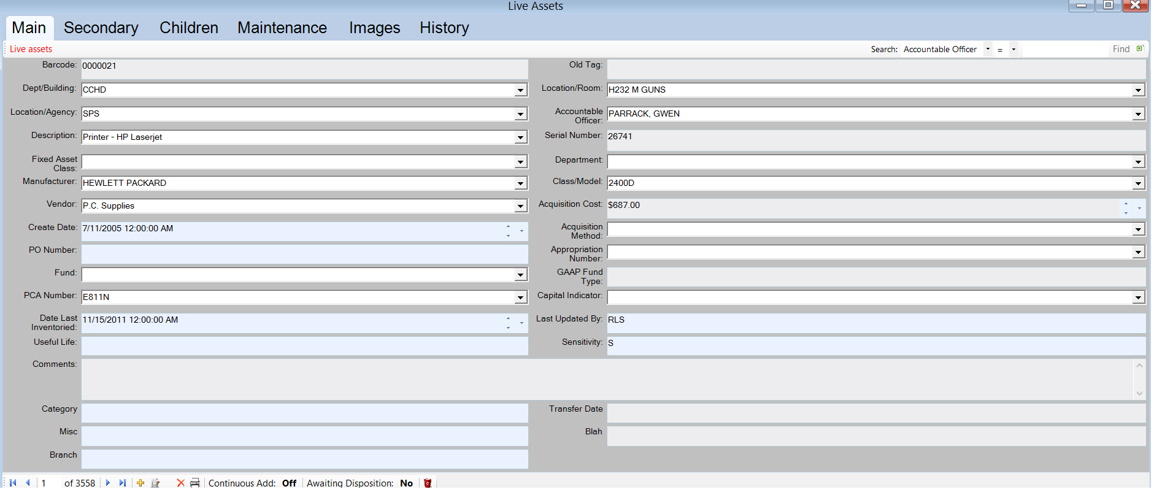
Disposed Assets 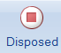
The Disposed assets are ALL inactive inventory items. This is the option where you can edit, delete, print and UNDISPOSE each item in your disposed table.
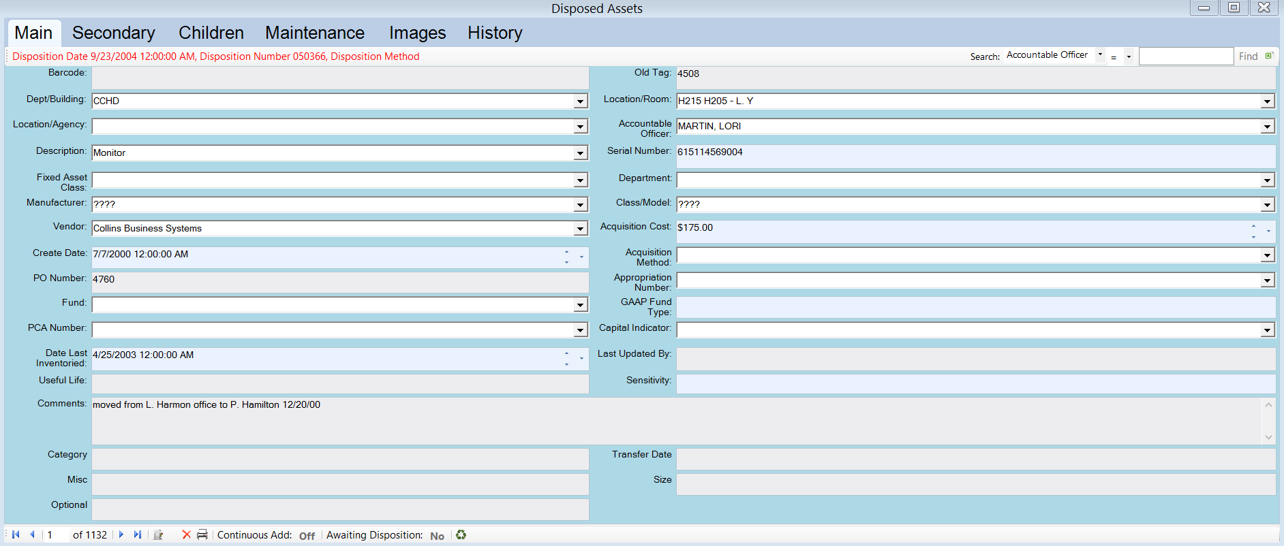

ASSET EXPLORER 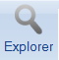
Your MITS application also includes a unique feature to “browse” your database in a number of ways to locate and in turn edit the record.
MITS utilizes a “Tree, Branch and Leaf” approach to locating your assets. This function is active for your LIVE and DISPOSED assets table.
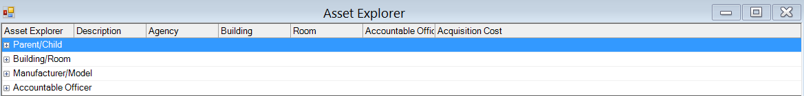
You have the ability to utilize either the parent/Child, Building/Room, Manufacturer/Model or Accountable officer as your search criteria.
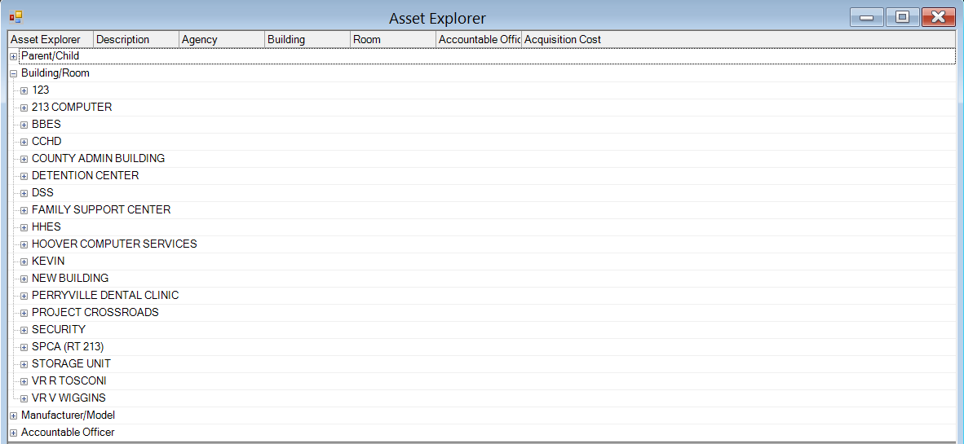

This tool is a very easy approach to locate and edit assets within your system.

REPORTS 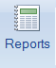
Included with your MITS application is a very robust reporting capability. This gives the user the full capability to report for both Live and Disposed assets. There is also a feature to create your own reports with a very simple to use “Filter” process. YOU include as many fields as you desire.
All reports are available in preview mode and may be saved in a myriad of formats to include PDF, Excel, JPEG, BMP and several other options.
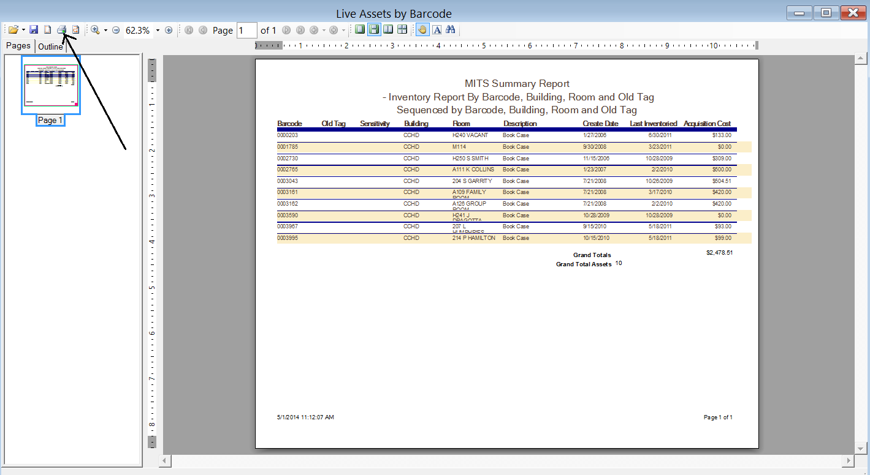
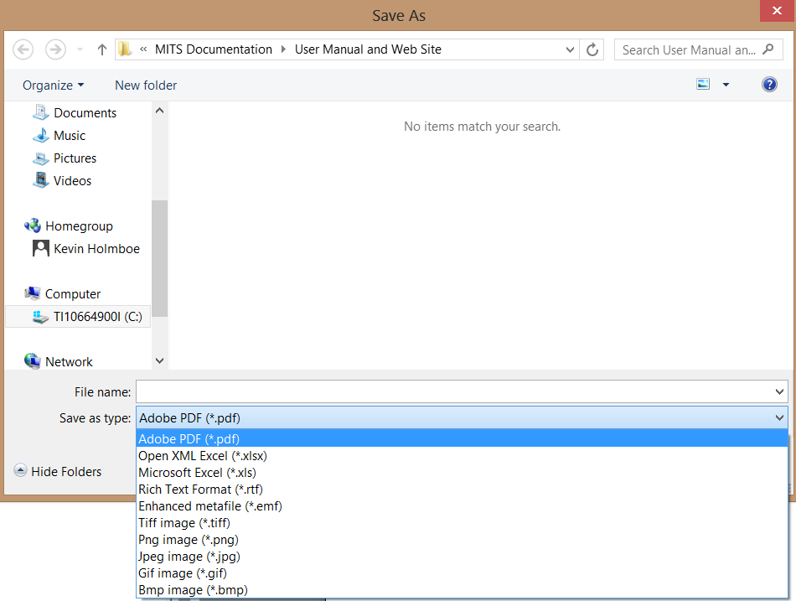
PENDING DISPOSITION FORM 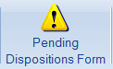
As part of your MITS application, you can move your assets into an automated Disposal form.
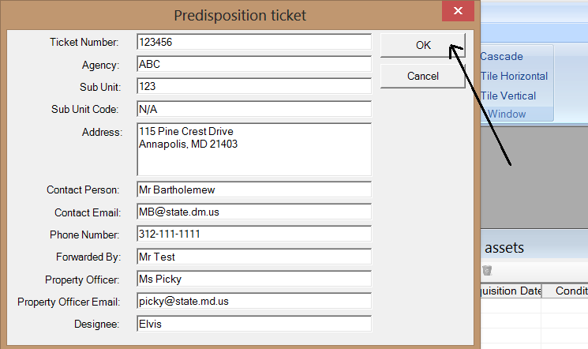
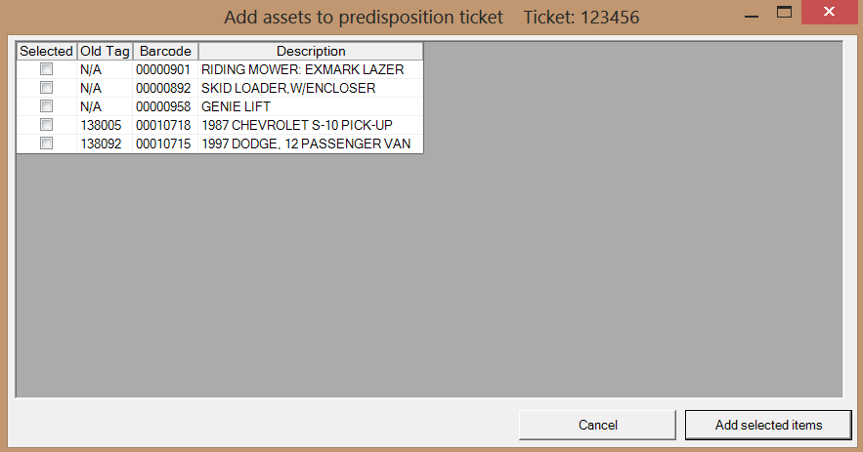

SCANNER 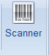
As part of the MITS application, you will utilize the barcode scanner to collect the First Inventory, Inventory or Transfer information.
The MITS system will quickly reconcile your inventory while providing immediate feedback of any missing or items which are not entered into inventory.
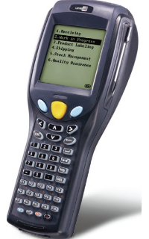

ADMIN MENU
As part of the MITS application, we have included this separate MENU to handle the administrative elements.
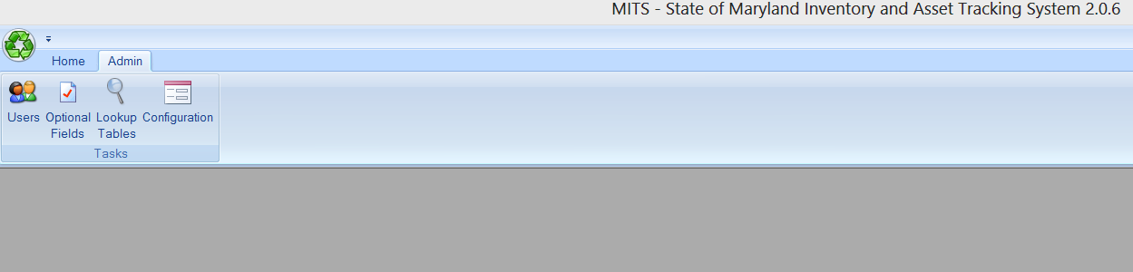

USERS 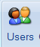
As part of the MITS application, you may assign the users and subsequent rights to the system.
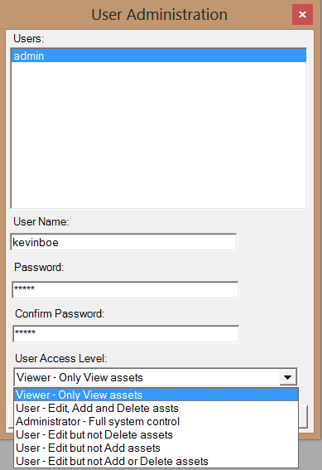

OPTIONAL FIELDS 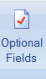
Included in the MITS application is up to 6 optional fields that YOU can name any way you want to. These fields are also available to you in the report Filters to select from.
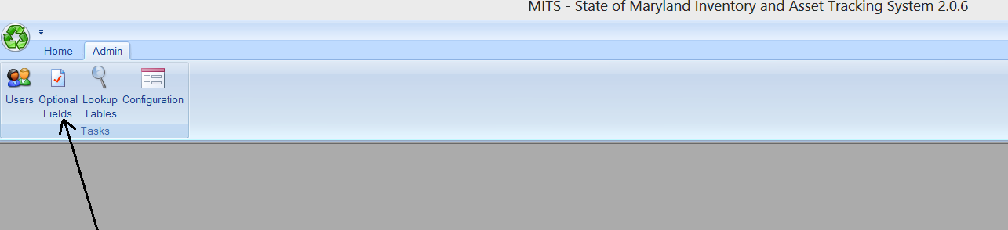
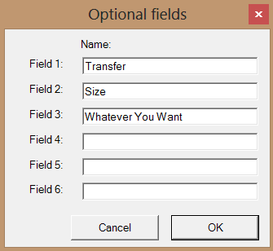
LOOKUP TABLES 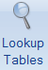
As part of the MITS application, you are able to maintain your tables of every important field such as Description, Location, Vendor, etc.
